**A PROJECT REPORT**

# ON

# “HOSPITAL MANAGEMENT SYSTEM”

**SUBMITTED BY:**

**MR. DINESH JADHAV**

**MR. UMESH SHINDE**

**MR. SAJAN ADE**

**MR. KUNAL UIKE**

**MR. ASHIT JAMNIK**

**FOR THE SUBJECT**

**SOFTWARE ENGINEERING**

**SUBJECT INCHARGE**

## PROF. R.V.DESHMUKH



**DEPARTMENT OF COMPUTER ENGINEERING**

**JAGADAMBHA COLLEGE OF ENGINNERING & TECHNOLOGY,**

**YAVATMAL, MAHARASHTRA, INDIA, 444501**

**SESSION 2022-2023**

**DEPARTMENT OF COMPUTER ENGINEERING, JCOET YAVATMAL CERTIFICATE**

**This is to certify that this Project Report titled**

**“Hospital Management System”**

**By**

**MR.DINESH JADHAV**

**MR. ASHIT JAMNI**

**MR. KUNAL UIKE**

**MR. UMESH SHINDE**

**MR. SAJAN ADE**

Of 3rd year B.E. during the academic year 2022-23 is submitted in their partial fulfillment for requirement of the award of the degree of bachelor of Engineeringin Computer Engineering under the Sant Gadge Baba Amravati University, Amaravati.

**Prof. R.V. Deshmukh**

**(Guided By)**

## Prof.P. D. Thakare

**(Head of Department)**



DEPARTMENT OF COMPUTER ENGINEERING

JAGADAMBHA COLLEGE OF ENGINNERING & TECHNOLOGY,

YAVATMAL, MAHARASHTRA, INDIA, 444501

SESSION 2022-2023

# ACKNOWLEDGMENT

It Gives a great pleasure to submit project titled “ **HospitalManagement**

**System**”. I wish to take this opportunity to express my Heartiest gratitude with pleasure to JCOET, Yavatmal. Which gives an opportunity infulfilling my host cherished desire my reaching my goals.

We Indebted to my proactive guide and class incharge**Prof. R.V. Deshmukh** Asst. Prof. of Computer Engineering Department because without his valuable guidance this work would not have a success. His constructive, useful, timely suggestions and encouragement in every step immensely helped we to carry out our seminar work.

I am very much indebted to **HOD P. D. Thakare&PrincipalDr.H.M.Baradkar**, for providing all the facilities needed for successful completion of this seminar and providing necessary assistance while preparing for this seminar.

I am very much thankful to Professors, Lecturers & Staff Members of Computer Engineering Department. I express my deep gratitude to my parents and all my friends who directly and indirectly helped to prepare for this seminar.

# ABSTRACT

The purpose of the project entitled as “**HOSPITAL MANAGEMENT SYSTEM**” is to computerize the Front Office Management of Hospital to develop software which is user friendly simple, fast, and cost – effective. It deals with the collection of patient’s information, diagnosis details, etc. Traditionally, it was done manually. The main function of the system is register and store patient details and doctor details and retrieve these details as and when required, and also to manipulate these details meaningfully System input contains patient details, diagnosis details, while system output is to get these details on to the screen. The Hospital Management System can be entered using a e-mail and password. It is accessible either by an administrator or receptionist. Only they can add data into the database. The data can be retrieved easily. The data are well protected for personal use and makes the data processing very fast.

# INDEX

|  |  |  |
| --- | --- | --- |
| **SR NO.** | **CONTENTS** | **Page No.** |
| 1 | INTRODUCTION | 1 |
| 2 | SCOPE OF PROJECT | 2 |
| 3 | MODULES | 3-5 |
| 4 | BENEFITS OF HOSPITAL  MANAGEMENT SYSTEM | 5 |
| 5 | HARDWARE REQUIREMENT | 6 |
| 6 | SOFTWARE REQUIREMENT | 6 |
| 7 | FEASIBILITY STUDY | 7 |
| 8 | DIAGRAM | 8 |
| 9 | WORKING | 9 |
| 10 | CONCLUSION | 10 |

## INTRODUCTION

The project “**Hospital Management system”** includes registration of patients, storing their details into the system, and also computerized billing in the pharmacy, and labs. The software has the facility to give a unique id for every patient and stores the details of every patient and the staff automatically. It includes a search facility to know the current status of each room. User can search availability of a doctor and the details of a patient using the id.

The Hospital Management System can be entered using a **e-mail and password.** It is accessible either by an administrator or receptionist. Only they can add data into the database. The data can be retrieved easily. The interface is very user-friendly. The data are well protected for personal use and makes the data processing very fast.

Hospital Management System is powerful, flexible, and easy to use and is designed and developed to deliver real conceivable benefits to hospitals.

**Hospital Management System** is designed for multispecialityhospitals, to cover a wide range of hospital administration and management processes. It is an integrated end-to-end Hospital Management System that provides relevant information across the hospital to support effective **decision making for patient care**, **hospital administration** and **critical financial accounting**, in a seamless flow.

Hospital Management System is a software product suite designed to improve the quality and management of hospital management in the areas of clinical process analysis and activity-based costing. Hospital Management System enables you to develop your organization and improve its effectiveness and quality of work. Managing the key processes efficiently is critical to the success of the hospital helps you manage your processes

**Scope of the Project**

* Information about Patients is done by just writing the Patients **name, age** and **gende**r. Whenever the Patient comes up his information is stored freshly.
* Bills are generated by recording price for each facility provided to patient on a separate sheet and at last they all are summed up.
* Diagnosis information to patients is generally recorded on the document, which contains Patient information. It is destroyed after some time period to decrease the paper load in the office.
* Immunization records of children are maintained in pre-formatted sheets, which are kept in a file.
* Information about various diseases is not kept as any document. Doctors themselves do this job by remembering various medicines.

All this work is done manually by the receptionist and other operational staff and lot of papers are needed to be handled and taken care of. Doctors have to remember various medicines available for diagnosis and sometimes miss better alternatives as they can’t remember them at that time.

**MODULES:**

The entire project mainly consists of 7 modules, which are

* + Admin module
  + User module (patient)
  + Doctor module
  + Nurse module
  + Pharmacist module
  + Laboratories module
  + Accountant module

**1. Admin module:**

* Manage department of hospitals, user, doctor, nurse, pharmacist, laboratoriesaccounts.
* Watch appointment of doctors
* Watch transaction reports of patient payment
* Bed, ward, cabin status
* Watch blood bank report
* Watch medicine status of hospital stock
* Watch operation report
* Watch birth report
* Watch diagnosis report
* Watch death report

**2.Patient module:**

* View appointment list and status with doctors
* View medication from doctor
* View doctor list
* View blood bank status
* View operation history
* View admit history, like bed, ward, ICUetc

**3. Doctor module:**

* Manage patient, account opening and updating
* Create, manage appointment with patient
* Create prescription for patient
* Provide medication for patients
* Issue for operation of patients and creates operation report
* Manage own profile

1. **Nurse module:**

* + Manage patient. account opening and updating
  + Allot bed, ward, cabin for patients
  + Provide medication according to patient prescription
  + Keep record of patient operation, baby born and death of patient
  + Manage own profile

1. **Pharmacist module:**

* Maintain medicine
* Keep records of hospitals stock medicines and status
* Manage medicine categories
* Watch prescription of patient
* Provide medication to prescriptions

**6. Laboratories module:**

* Watch prescription list
* Upload diagnostic report
* Preview of report files, like x-ray images, CT scan, MRI reports
* Manage own profile

**7. Accountant module:**

* Create invoice for payment
* Order invoice to patient
* Take cash payment
* Watch payment history of patients
* Manage own profile

BENEFITS OF HOSPITAL MANAGEMENT

SYSTEM–

* Achieve good quality ratings.
* Better revenue management.
* Avoid errors and track every singledetails.
* Improved clinical decision making. ▪ Improve data security.
* Establish hospital as technically advance.

**HARDWARE REQUIREMENTS FOR PROJECT:**

PROCESSOR -Intel Core , i3

**SOFTWARE REQUIREMENTS FOR PROJECT:**

OPERATING SYSTEM - Windows operating system

FRONT END-PYTHON

DATABASE – XAMPP SERVER

### FEASIBILITY STUDY

The feasibility of the project is analysis in this phase and business proposal is put forth with a very general plan for the project and some cost estimates. During system analysis the feasibility study of the proposed system is to be carried out. This is to ensure that the proposed system is not a burden to the company. For feasibility analysis, some understanding of the major requirements for the system is essential.

#### 1.Economic Feasibility

This study is carried out to check the economic impact will have on the system will have on the organization. The amount of fund that the company can pour into the research and development of the system is limited. The expenditures must be justified.Thus the developed system as well within the budget and this was achieved because most of the technologies used are freely available. Only the customised products have to be purchased.

#### 2.Technical Feasibility

This study is carried out to check the technical feasibility, that is the technical requirements of the system. Any system developed must not have a high demand on the available technical resources. This will lead to high demands being placed on the client. The developed system must have a modest requirement, as only minimal or null changes for the implementing this system.

#### 3.Operational Feasibility

The aspect of study is to check the level of acceptance of the system by the user. This includes the process of training the user to use the system efficiently. The user must not feel threatened by the system, instead must accept it as a necessity. The level of acceptance by the users solely depends on the methods that are employed to educate the user about the system and to make them familiar with it. Their level of confidence must be raised so that theyare also able to make some constructive criticism, which is welcomed, as theyare thefinal user of the system.

**Use case diagram of project:**

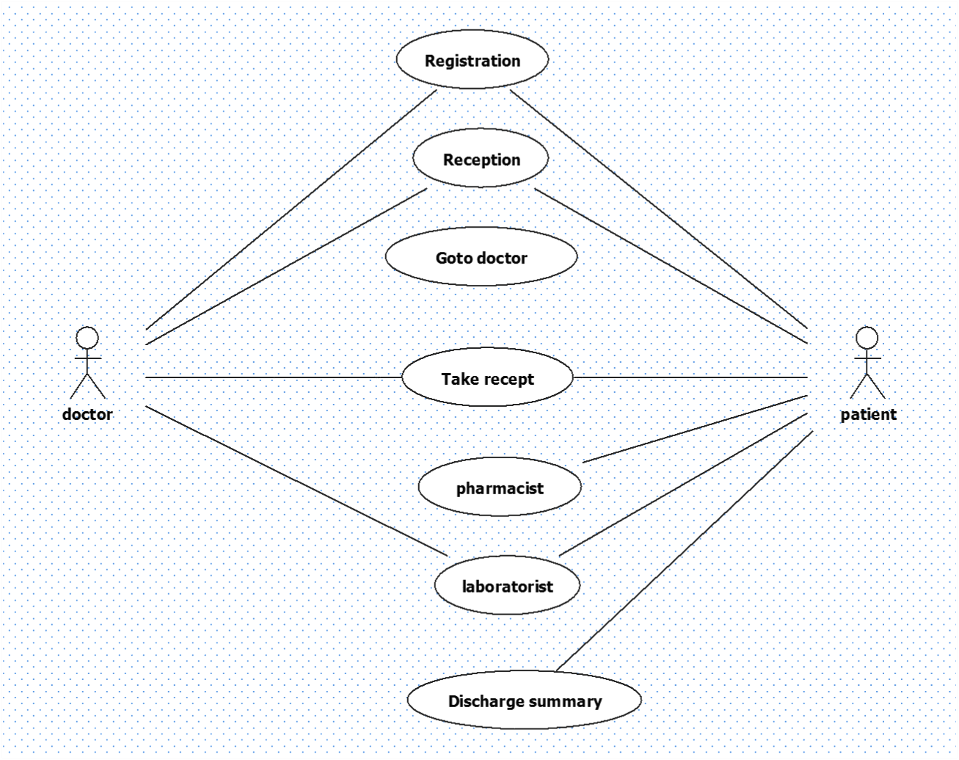

### WORKING

Hospital Management System helps to manage all information related with patients.It stores medical history,treatment details,fess details and so on..

Hospital Management System collects all such information and receptionist can easily check the information from the system.

Hospital Management System provide the ability to manage all paper work at one place and reducing the work of staff in arrranging and analyzing the paper work of the patient. 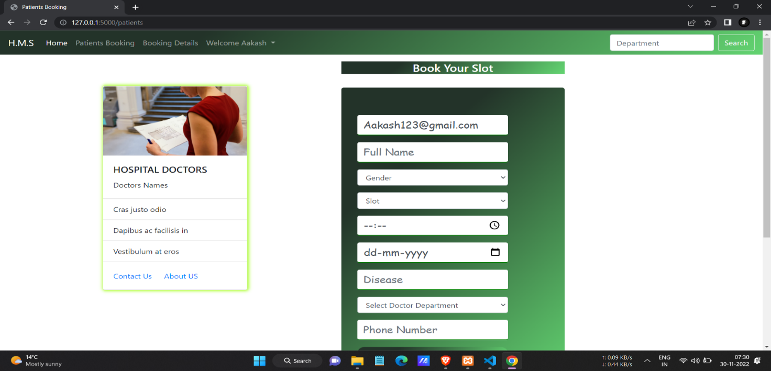

Record will be store in database

**CONCLUSION:**

Since we are entering details of the patients electronically in the **“Hospital Management System”,** data will be secured. Using this application we can retrieve patient’s history with a single click. thus processing information will be faster. It guarantees **accurate maintenance** of patient details. It easily reduces the book keeping task and thus reduces the human effort and increases accuracy speed.

**Referances:**

The “**Hospital Management System**” is 24*7 system provide service to the hospital staff to find the information about patient. Everyone staff can handle the management system.

* referance from <https://mocdoc.in/blog>.
* referance from <https://www.mygreatlearning.com/blog>
* referance from <https://www.interviewbit.com/blog>